Seminar 4 Examples

Accrued interest
- A bond pays a semiannual coupon, and the last coupon was paid 61 days ago. If the annual coupon payment is $5, what is the accrued interest? (Assume 182 days in the 6-month period.)

(5/2) × (61/182) = $12.5

- A bond has a flat price of $985, and it pays an annual coupon. The last coupon payment was made 90 days ago. What is the invoice price if the annual coupon is $69?

Invoice = 985 + (69)(90/365) = $1,002.01

- A bond has a 5% coupon rate. The coupon is paid semiannually, and the last coupon was paid 35 days ago. If the bond has a par value of $1,000, what is the accrued interest?

Accrued interest = (50/2) × (35/182) = 4.81

- The price on a Treasury bond is 104.3625, with a yield to maturity of 3.45%. The price on a comparable maturity corporate bond is 103.5, with a yield to maturity of 4.59%. What is the approximate percentage value of the credit risk of the corporate bond?

Risk Premium= 0,0459-0,0345=0,0114 or 1.14%

- The price of a bond (with par value of $1,000) at the beginning of a period is $980 and at the end of the period is $95. What is the holding-period return if the annual coupon rate is 4.5%?

HPR = [(95 + 45 - 980)/980] - 1 = 4.08%

- A coupon bond that pays interest annually has a par value of $1,000, matures in 5 years, and has a yield to maturity of 12%. If the coupon rate is 9%, the intrinsic value of the bond today will be _________.

PV=$891.86 (par=1000, N=5, i=0.12, coupon=90 or 9%)

Duration
- (354/1.) Rank the following bonds in order of descending duration.
Bond | Coupon | Time to Maturity | Yield to Maturity
A | 15% | 20 years | 10%
B | 15% | 15 years | 10%
C | 0 | 20 years | 10%
D | 8% | 20 years | 10%
E | 15% | 15 years | 15%
Solution:
C: Highest maturity, zero coupon
D: Highest maturity, next-lowest coupon
A: Highest maturity, same coupon as remaining bonds
B: Lower yield to maturity than bond E
E: Highest coupon, shortest maturity, highest yield of all bonds.

- (352/8.) Find the duration of a 6% coupon bond making annual coupon payments if it has three years until maturity and a yield to maturity is 6%? What is the duration if the yield to maturity is 10%?

Solution:
- Computation of duration:
  - YTM = 6%
(1) | (2) | (3) | (4) | (5)
Time until Payment (Years) | Payment | Payment Discounted at 6% | Weight | Column (1)  ×  Column (4)
1 | 60 | 56.60 | 0.0566 | 0.0566
2 | 60 | 53.40 | 0.0534 | 0.1068
3 | 1060 | 890.00 | 0.8900 | 2.6700
Column Sum: |  | 1000.00 | 1.0000 | 2.8334

Duration = 2.833 years

  - YTM = 10%

(1) | (2) | (3) | (4) | (5)
Time until Payment (Years) | Payment | Payment Discounted at 10% | Weight | Column (1)  ×  Column (4)
1 | 60 | 54.55 | 0.0606 | 0.0606
2 | 60 | 49.59 | 0.0551 | 0.1101
3 | 1060 | 796.39 | 0.8844 | 2.6531
Column Sum: |  | 900.53 | 1.0000 | 2.8238

Duration = 2.824 years, which is less than the duration at the YTM of 6%

- (333/11.1) A bond with a maturity of 3 years has a coupon of 8 percent (paid annually) and a yield to maturity of 10 percent.
  - Calculate its price.
  - Calculate its duration.
Solution:
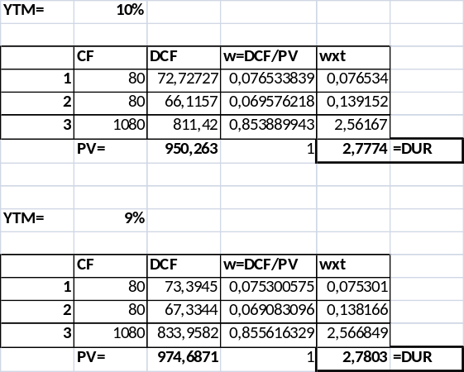

- A pension fund must pay out $1 million next year, $2 million the following year, and then $3 million the year after that. If the discount rate is 8%, what is the duration of this set of payments?

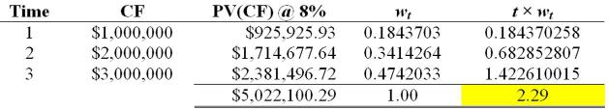

- Compute the duration of an 8%, 5-year corporate bond with a par value of $1,000 and yield to maturity of 10%.

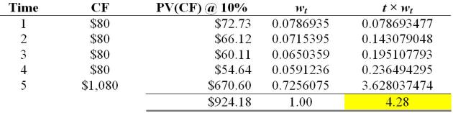

- (336/3) A 9 percent coupon, 8-year maturity bond with annual payments, selling at a yield to maturity of 10%.
- Calculate the duration of this bond.
- What would its duration be if the bond paid its coupon semi-annually?
- Why intuitively does duration fall?
Solution:
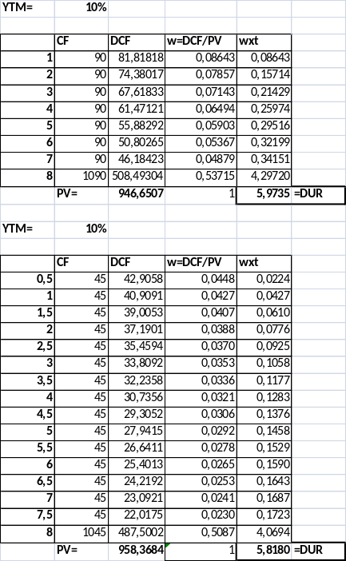
- (335/2.) The bond has a 3-year maturity, an 8 percent coupon, and sells at an initial yield to maturity of 9 percent.
  - Calculate the price of the bond.
  - Calculate the modified duration of the bond.
  - Calculate the convexity of the bond.
  - If the bond’s yield increases from 9% to 9.05%, what will be the bond price?
  - Calculate the bond new price with the duration formula.
  - Calculate the bond new price with the convexity formula.

Solution:
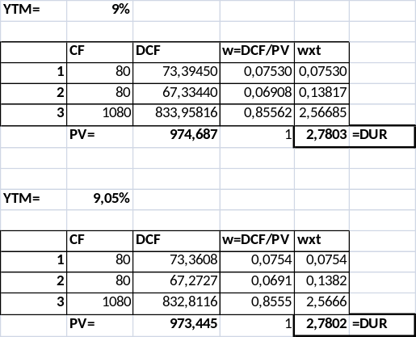
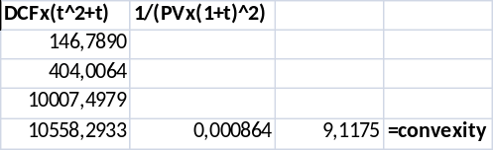
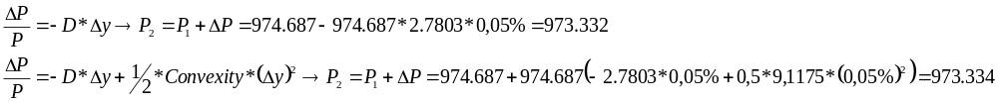
Immunization
- (345/7) How would an increase in trading costs affect the attractiveness of dedication versus immunization?

Solution:
Dedication would be more attractive. Cash flow matching eliminates the need for rebalancing and, thus, saves transaction costs.

- (352/10.) A pension plan is obligated to make disbursements of $1 million, $2 million, and $1 million at the end of each of the next three years, respectively. Find the duration of the plan’s obligations if the interest rate is 10% annually.

Solution:
Computation of duration, interest rate = 10%:

(1) | (2) | (3) | (4) | (5)
Time until Payment (Years) | Payment  (in millions of dollars) | Payment Discounted  At 10% | Weight | Column (1)  ×  Column (4)
1 | 1 | 0.9091 | 0.2744 | 0.2744
2 | 2 | 1.6529 | 0.4989 | 0.9977
3 | 1 | 0.7513 | 0.2267 | 0.6803
Column Sum: |  | 3.3133 | 1.0000 | 1.9524

Duration = 1.9524 years

